**SAVEEETHA SCHOOL OF ENGINEERING**

**CSA1142-OBJECT ORIENTED ANALYSIS AND DESIGN**

**QUESTION 22: ONLINE INSURANCE MANAGEMENT SYSTEM**

**USE CASE**

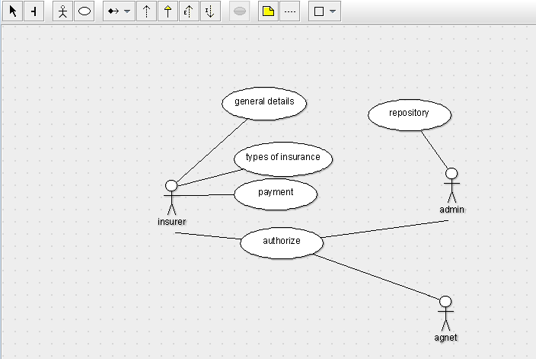

STATE DIAGRAM

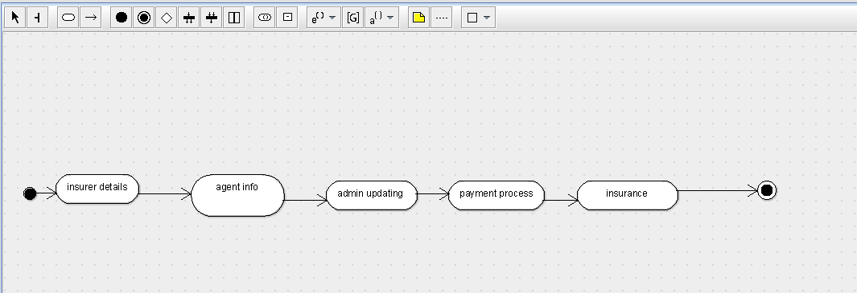

SEQUENCE DIAGRAM

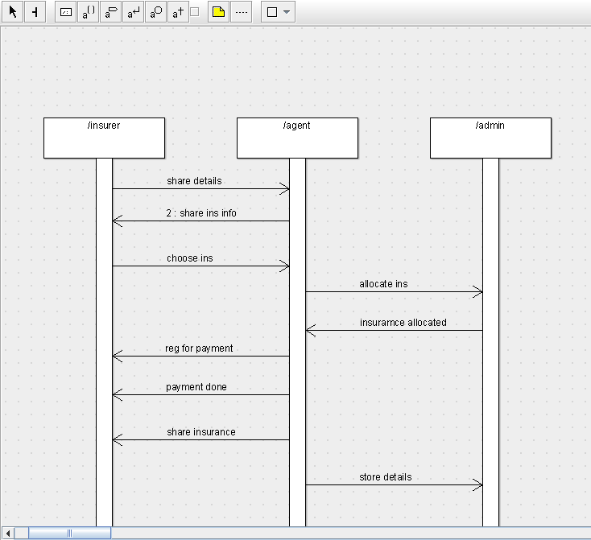

DEPLOYMENT DIAGRAM

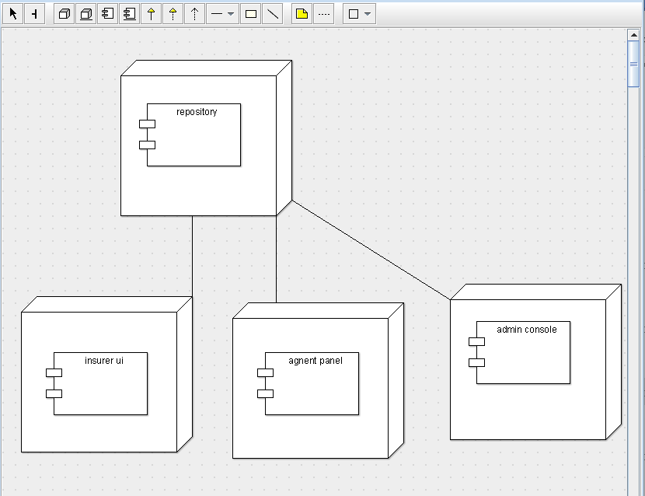

COMPONENT DIAGRAM

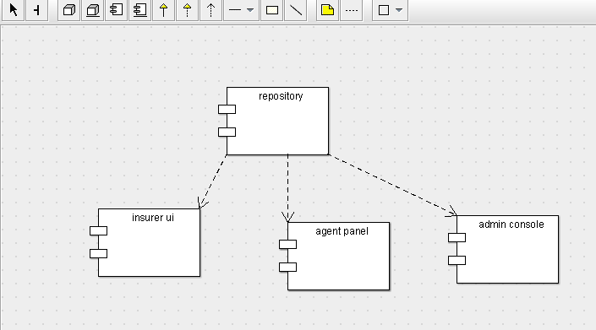

COLLABORATION DIAGRAM

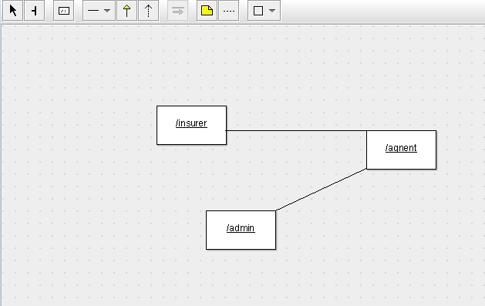

CLASS DIAGRAM

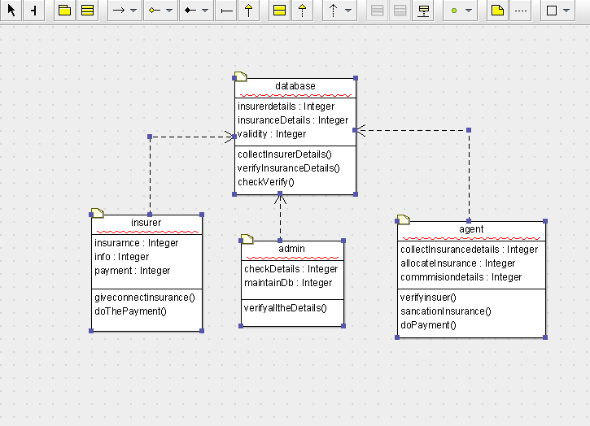

ACTIVITY DIAGRAM

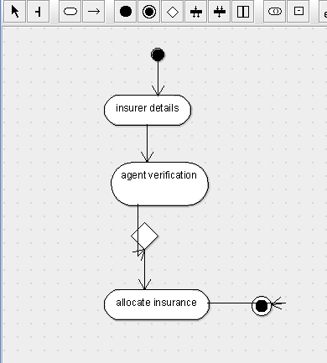

SKELETON CODE;

public class database {

  public Integer insurerdetails;

  public Integer insuranceDetails;

  public Integer validity;

  public void collectInsurerDetails() {

  }

  public void verifyInsuranceDetails() {

  }

  public void checkVerify() {

  }

}

public class insurer {

  public Integer insurarnce;

  public Integer info;

  public Integer payment;

  public void giveconnectinsurance() {

  }

  public void doThePayment() {

  }

}

public class agent {

  public Integer collectInsurancedetails;

  public Integer allocateInsurance;

  public Integer commmisiondetails;

  public void verifyinsuer() {

  }

  public void sancationInsurance() {

  }

  public void doPayment() {

  }

}

public class admin {

  public Integer checkDetails;

  public Integer maintainDb;

  public void verifyalltheDetails() {

  }

}